Chapter 8, Solution 17.

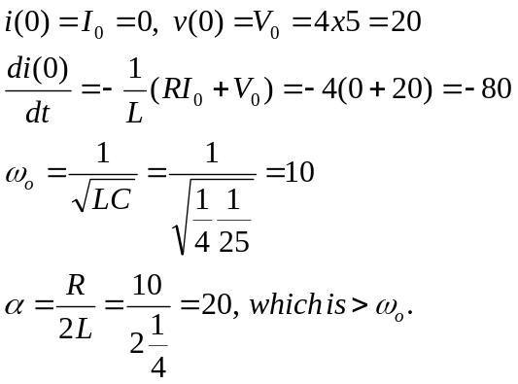
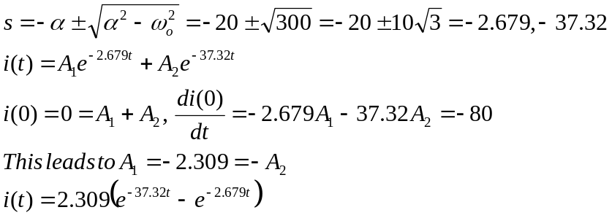

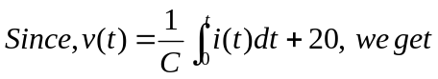

v(t) = [21.55e^{-2.679t} – 1.55e^{-37.32t}] V

